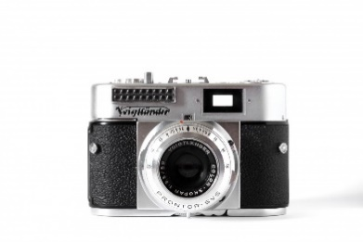
2025-26 MDA YEARBOOK
ORDER FORM
Student Name: _____________________________________________
Teacher Name: ______________________________________________
Grade: ___________ Qty: ____x$21.25 = ___________Total
Parent/Guardian Name: ______________________________________
Phone Number: _____________________

Option 1: Preferred Payment – Visit https://hrce.schoolcashonline.com & register for an account (if not already registered). Purchase yearbook online using credit card or echeck. To receive notifications, click on My Account – Manage email notifications.
Option 2: Bring cash or cheque (payable to Marine Drive Academy) and this form to your homeroom teacher by May 15, 2026.

Contact samantha.bateman@hrce.ca with questions/concerns.

* We only order the number of copies that we sell so please make sure to order by May 15th.

